EXERCISE-22

22.Design DFA using simulator to accept odd number of a’s

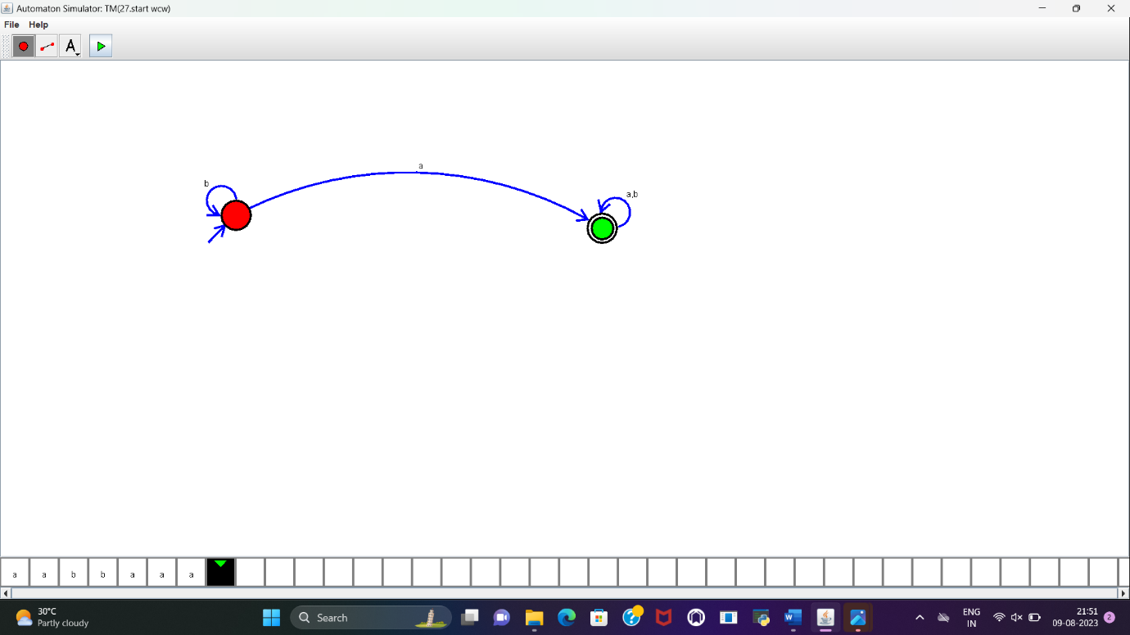

RESULT:

DFA to accept odd number of a’s is designed and implemented successfully.